Low Level Design (add EMPLOYEE module)

Project Code | Team2
Project Name | Employee Maintenance System

Prepared/Modified by | Role | Date of Preparation
Neha Gaonkar | Software Engineer | 23/10/2016
Reviewed by | Role | Date of Review
Nikita Gavand | Software Engineer | 27/10/2013
Approved by | Role | Date of Approval
Kavita Arora | Training Manager
Circulation List | nikita.gavand@capgemini.com  madhulika.patole@ capgemini.com  neha.a.gaonkar@ capgemini.com  pawankumar.kirdat@ capgemini.com  trupti.sangekar@ capgemini.com  krishnakant.alle@ capgemini.com | Version Number of the template:1.0
Version Number | 1.3

Table of Contents

1. Description Of The Unit 3
2. References 4
3. Dependencies / Assumptions 5
4. Class Diagrams 6
5. Sequence Diagrams 7
6. Design Components 8
6.1 List Of UI Components 8
6.2 List Of Design Classes 8
7. Re-Usable Routines/Components 9
8. Messages 10
9. Configuration Files 11
10. Crud Matrix Table 12
11. Data Mapping Matrix 13
12. Action Flow Matrix 14
13. Stored Procedures 15
14. Program Specification / Pseudo Code 16
REVISION HISTORY OF THE WORK 17

Description Of The Unit

The add employee module allows the admin of the application to add the employee into the database. This module can be used only by the admin of the application.

On clicking on the add button in the admin home page, the admin is redirected to a add page. The admin enters all the details of the employee like employee name, date of birth, date of joining, department id, grade, designation, salary, gender, marital-status, address, contact-number. If the entered employee details are invalid, appropriate error messages are displayed.

After entering all the employee details, the details are inserted into the database on clicking the add button.

References

Reference | Description
Class Diagram | /Project Documents/Design Documents/HLD/Class Diagrams
URS | /Project Documents/Requirements/Case Study/Employee Maintenance System( Team 2 Nikita).doc
UTP | /Project Documents/Test Plan/UTP/Test Cases/AddEmployee /UTP_AddEmployeeModule.xlsm
DB Design | /Project Documents/Design Documents/HLD/DB Design/AddEmployee _GROUP_DBDESIGN.xls

Dependencies / Assumptions

Dependencies:
The admin should be logged in.

Assumptions:
The admin details are stored in the database.

Class Diagrams

Class Diagram

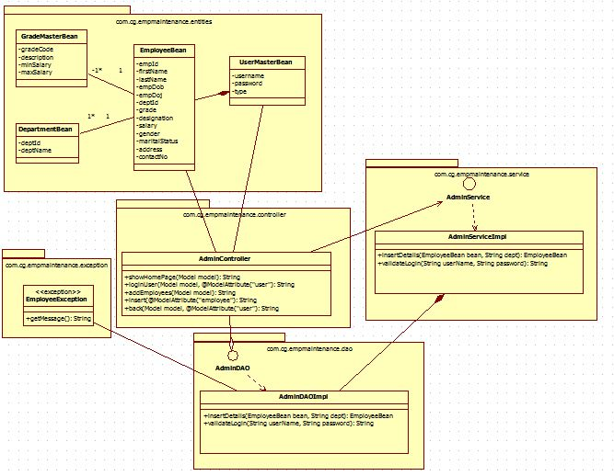

Sequence Diagrams

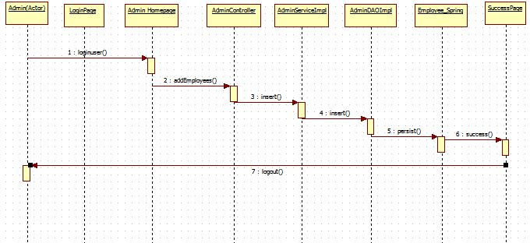

Design Components

List Of UI Components

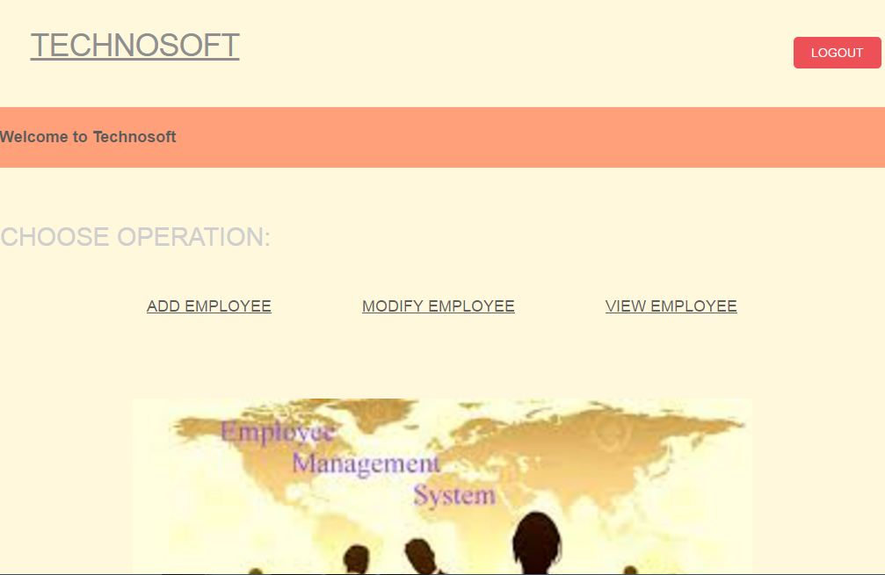

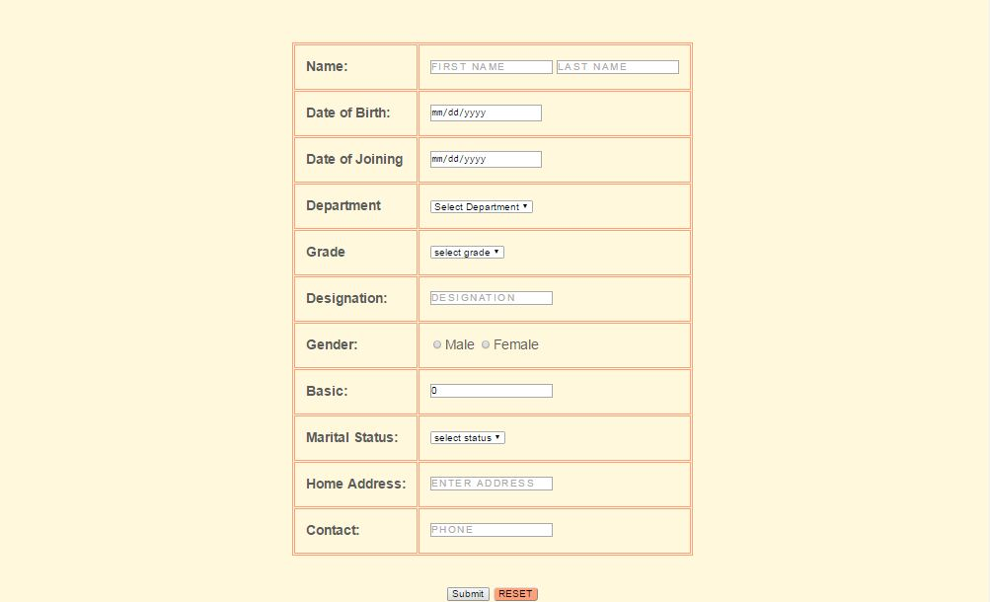

6.2 List Of Design Classes

Sr. No. | LLD Name | Class Name | Method Name | Method Description
1 | Add Employee Module | EmployeeBean, UserMasterBean, DepartmentBean, GradeMasterBean | Appropriate getters and setters methods | Getters retrieve the property values and setters set the property values
2 | Add Employee Module | AdminController | @RequestMapping("/add")  public String addEmployees(Model model)  @RequestMapping(value = "/insert", method = RequestMethod.POST)  public String insert(  @ModelAttribute("employee") @Valid EmployeeBean employee,  BindingResult result, @RequestParam("DepartmentName") String dName, Model model) | Sets the model attribute.  InsertDetails(EmployeeBean bean)of ADminDAOImpl class. If it returns object then it redirects to home page else it redirects to add page with appropriate error message.

Re-Usable Routines/Components

Re-Usable Routines/Components

- CSS files
- Javascript files
- DataAccessException class
- Database properties files
- Logger properties files

Messages

#. | Type | Message Text
M1 | Error | Enter a valid employee name
M2 | Error | Enter a valid date
M3 | Error | Select the grade based on salary
M4 | Error | Enter a valid address
M5 | Error | Enter a valid contact number
M6 | Error | This field cannot be empty

Configuration Files

File Name | Path | Description
oracle.properties | /Development/Source | To configure database connection.
Web.xml | /Development/Source | To configure the bean properties.
Dispatcher-servlet.xml | /Development/Source | To configure the request mapping and view resolver.
Employee_logger.properties | /Development/Source | To configure the logger.
Employee_error.properties | /Development/Source | To configure error messages.

Crud Matrix Table

# | Table Name | Create | Read | Update | Delete
1. | Employee | Y | Y | Y | Y
2. | Department | Y | N | N | N
3. | Emp_id_Seq | Y | N | N | N
4. | Grade | Y | N | N | N

Data Mapping Matrix

Sr. No. | Screen Label | Field Source | Field Type | Data Type | Max Length | Data Flow | Mandatory
1 | Employee Name | NA | Label | NA | NA | UI | NA
2 | EmployeeName | EmployeeBean.firstName,  EmployeeBean.lastName | TextBox | Varchar2 | 25 | UI→D | Yes
3 | Employee DOB | NA | Label | NA | NA | UI | NA
4 | EmployeeDOB, Employee DOJ | EmployeeBean.empDob  EmployeeBean.empDoj | TextBox | Date | NA | UI→D | Yes
5 | Employee dept. id | NA | Label | NA | NA | UI | NA
6 | Employeedept_id | EmployeeBean.deptId | TextBox | Number | 38 | UI→D | Yes
7 | Employee Grade | NA | Label | NA | NA | UI | NA
8 | EmployeeGrade | EmployeeBean.grade | TextBox | Varchar2 | 2 | UI→D | Yes
9 | Employee Designation | NA | Label | NA | NA | UI | NA
10 | EmployeeDesignation | EmployeeBean.designation | TextBox | Varchar2 | 50 | UI→D | Yes
11 | Salary | NA | Label | NA | NA | UI | NA
12 | Salary | EmployeeBean.salary | TextBox | Number | 38 | UI→D | Yes
13 | Gender | NA | Label | NA | NA | UI | NA
14 | Gender | EmployeeBean.gender | Radio | Varchar2 | 1 | UI→D | Yes
15 | Marital Status | NA | Label | NA | NA | UI | NA
16 | Marital Status | EmployeeBean.maritalstatus | Dropdown | Varchar2 | 10 | UI→D | Yes
17 | Address | NA | Label | NA | NA | UI | NA
18 | Address | EmployeeBean.address | TextBox | Varchar2 | 100 | UI→D | Yes
19 | Contact number | NA | Label | NA | NA | UI | NA
20 | contactnumber | EmployeeBean.contactNo | TextBox | Varchar2 | 15 | UI→D | Yes
21 | Add | NA | Button | NA | NA | UI | NA
22 | Reset | NA | Button | NA | NA | UI | NA

Legend
D → UI (Database to User Interface)
UI → D (User Interface to Database)
UI (User Interface Only)

Action Flow Matrix

Sr. No. | Action | Description | Process
1 | On click of Add Button in Admin Homepage | Redirected to the Add page | The admin clicks on the add button in the admin homepage and gets redirected to the add page.
2 | On click of Add Employee button in add page | The employee details are inserted into the database. | Data is entered in the fields by the admin which gets inserted into the database when add button is pressed.
3 | On click of Reset button in Add page | The fields are cleared | The admin on clicking on the reset button in add page the fields are cleared.

Stored Procedures

# | Stored Procedure Name  (with Description) | Input/Out Parameters | Type | Size
1. | NA | NA | NA | NA

Program Specification / Pseudo Code

<ACTION :ADD_CLICK >

Pseudo Code:
- Client Side Scripting:
None

- Server Side Scripting:
BEGIN
Call AddEmployee (Model model) in Controller class
Navigate to add page
END

14. 2 <ACTION: ADDPRODUCT_CLICK>

Pseudo Code:

- Client Side Scripting:

IF invalid EmployeeName
Print Error Message M1
IF EmployeeName isEmpty
Print Error Message M6
IF invalid EmployeeDoj
Print Error Message M2
IF EmployeeDoj isEmpty
Print Error Message M6
IF EmployeeDob isEmpty
Print Error Message M6
IF invalid address
Print Error Message M4
IF address isEmpty
Print Error Message M6
IF invalid contactnumber
Print Error Message M5
IF contactnumber isEmpty
Print Error Message M6
IF grade is not based on salary
Print Error Message M3
IF grade isEmpty
Print Error Message M6

- Server Side Scripting:
BEGIN
Call public String insert(@ModelAttribute("employee") @Valid EmployeeBean employee,BindingResult result, @RequestParam("DepartmentName") String dName, Model model) in Controller class in Presentation Layer
BEGIN
Call insertDetails(EmployeeBean bean)in AdminServiceImpl class in Service Layer
BEGIN
Call insertDetails(EmployeeBean bean)in AdminDAOImpl class in Data Access Layer
BEGIN
Create query for insert records into Employee_spring
Return bean
END
Return bean. to Service Layer
END
Return bean to Presentation Layer

END
IF successful navigate to home page
Else navigate to add page and show error.
END

14. 2 <ACTION: RESET>

Pseudo Code:
1. Client Side Scripting:
None

2. Server Side Scripting:
BEGIN
Call gotohomepage (Model model) in Controller class
Navigate to home page
END

REVISION HISTORY OF THE WORK PRODUCT

# | Date | Version # | Section Changed | Details of changes made | Approved By
1 | 16/12/2013 | 1.0 | LLD prepared | N/A | Kavita Arora
2 | 17/12/2013 | 1.1 | Reusable components,  Pseudo code | Reusable components added.  The pseudo code is modified as per the specified flow. | Kavita Arora
3 | 18/12/2013 | 1.2 | Reusable components,  References,  Data Mapping Matrix. | Reusable Components added.  File name with relative path is added in the references section.  The name of text boxes(screen label is changed). | Kavita Arora
4 | 24/12/2013 | 1.3 | Configuration files,UI Components | Paths of the configuration files is updated and UI components(Screen Shots) added. | Kavita Arora

